

**HANOI UNIVERSITY**

**Faculty of Information Technology**

**CNE – Tutorial Guide**

**Week 5**

**IP Classless Addressing - CIDR**

**and Subnetting**

1. **Review previous tutorial**

IP Subnetting Step 1: Analyzing Requirements

IP Subnetting Step 2: Partitioning Network Address Host Bits

IP Subnetting Step 3: Determining the Custom Subnet Mask

IP Subnetting Step 4: Determining Subnet Identifiers and Subnet Addresses

IP Subnetting Step 5: Determining Host Addresses for Each Subnet

Please read this material:

http://www.tcpipguide.com/free/t_IPSubnettingPracticalSubnetDesignandAddressDetermi.htm

1. **IP CIDR Subnetting**

**1. Classless Inter-Domain Routing (CIDR):**

Classless Inter-Domain Routing (CIDR) is a system of IP addressing and routing that solves the many problems of “classful” addressing by eliminating fixed address classes in favor of a flexible, multiple-level, hierarchical structure of networks of varying size.

Since there are no address classes in CIDR, one cannot tell the size of the network ID of an address from the address alone. In CIDR, the length of the prefix (network ID) is indicated by placing it following a slash after the address. This is called *CIDR notation* or *slash notation*.

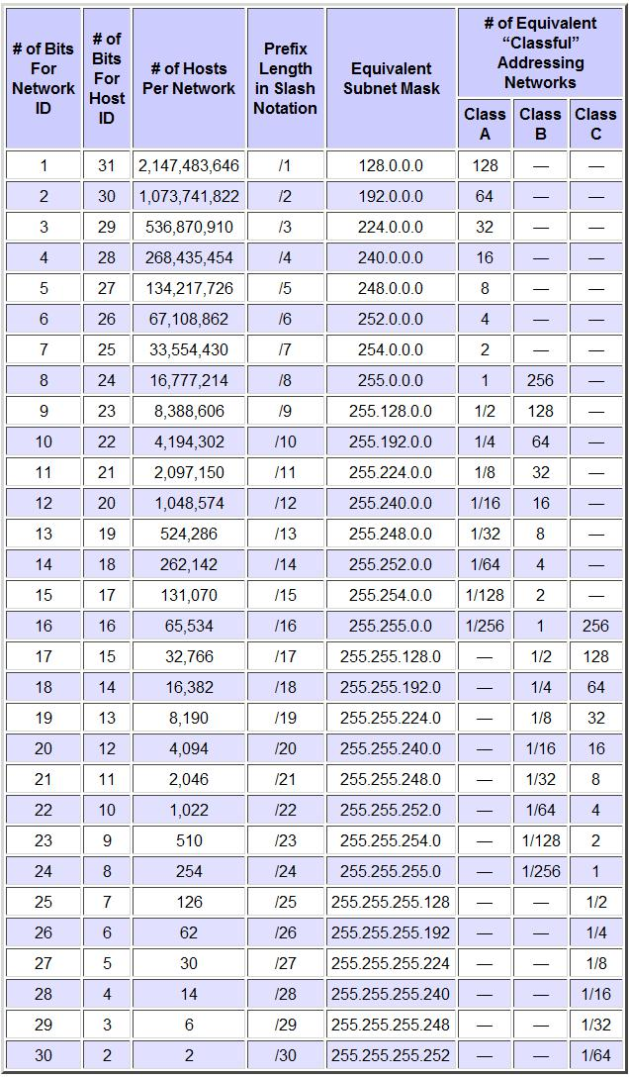

***Example:***

Classless Network:

210.245.52.0/26

26 bits for prefix length (Network ID) and 6 bits for Host ID:

**11010010 11110101 00110100 00**000000

Binary Subnet mask for /26 network:

**11111111 11111111 11111111 11**000000

Binary Subnet mask converted to dotted decimal:

255.255.255.192

**2. Subnetting:**

Subnetting occurs when we take an address prefix that correspond to a physical locale and extend it into longer sub-prefixes that correspond to smaller locales.

Now let’s try to subnet the original prefix:

Say you're responsible for administering the IP network of HANU. HANU is assigned a block of IP: 210.245.52.0/26. There are three new departments FIT, FMT and FCS. FIT has 20 PCs, FMT has 10 PCs and FCS has 5 PCs. Please assign IP addresses to each department.

1. Find the subnet mask for Address: 210.245.52.0 Prefix: /26
   * Look at the table of “CIDR Address Blocks and Classful Equivalents” above we can find the subnet mask for 210.245.52.0/26 is 255.255.255.192
   * Or you can look at this illustration to see the simple way we can do to find subnet mask:

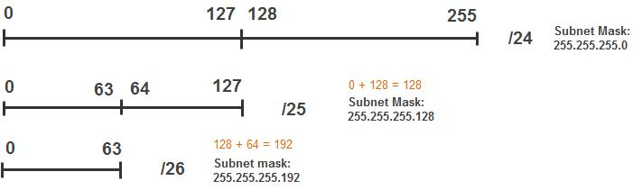

* Or we can use binary notation. See the example in the previous part.

1. Find the first address and the last address of IP block
   1. First IP address: 210.245.52.0, which is the network address
   2. Last IP address: 210.245.52.63, which is the broadcast address

* Look at the picture of subnetting in previous section, you can easily find out that the last IP address is 210.245.52.63
* Or we can use binary notation for clearer understanding:

|  |  |  |
| --- | --- | --- |
| **1st address:** | **11010010.11110101.00110100.00**000000 | (210.245.52.0) |
| **Subnet Mask:** | **11111111.11111111.11111111.11**000000 | (255.255.255.192) |
| **Last address:** | **11010010.11110101.00110100.00**111111 | (210.245.52.63) |

* 1. Valid IP address for this network is ranged from 210.245.52.1 – 210.245.52.62. So this network can have 62 hosts.

1. Divide the IP block 210.245.52/26 into smaller sub networks:

- **Tip:** Assign larger subnets before smaller ones, since it is much easier to wedge small subnets in between large ones than vice versa.

- First level of division:

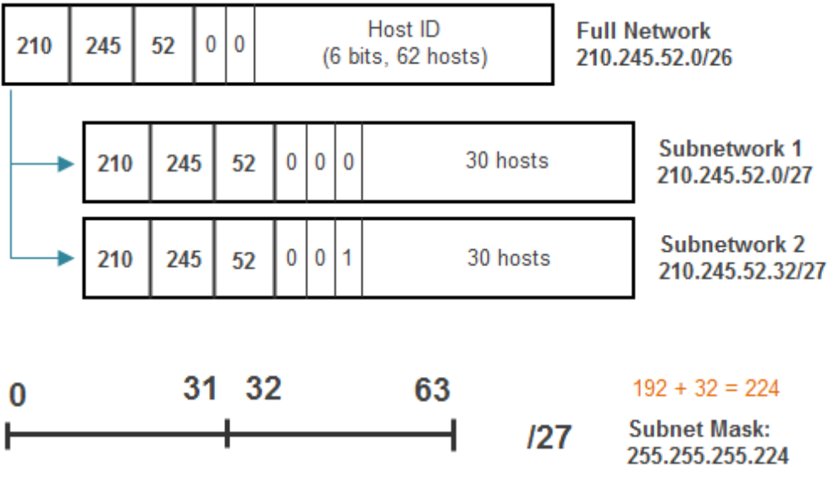

* Each subnetwork in the first level of division contains 30 hosts so we can use 1 subnetwork for FIT (20 PCs). For example, I use *subnetwork 1* for FIT.
* Subnetwork 1:

|  |  |  |
| --- | --- | --- |
| **1st address:** | **11010010.11110101.00110100.000**00000 | (210.245.52.0) |
| **Subnet Mask:** | **11111111.11111111.11111111.111**00000 | (255.255.255.224) |
| **Last address:** | **11010010.11110101.00110100.000**11111 | (210.245.52.31) |

* Subnetwork 2:

|  |  |  |
| --- | --- | --- |
| **1st address:** | **11010010.11110101.00110100.001**00000 | (210.245.52.32) |
| **Subnet Mask:** | **11111111.11111111.11111111.111**00000 | (255.255.255.224) |
| **Last address:** | **11010010.11110101.00110100.001**11111 | (210.245.52.63) |

* Continue dividing subnetwork 2 into two smaller subnetwork:

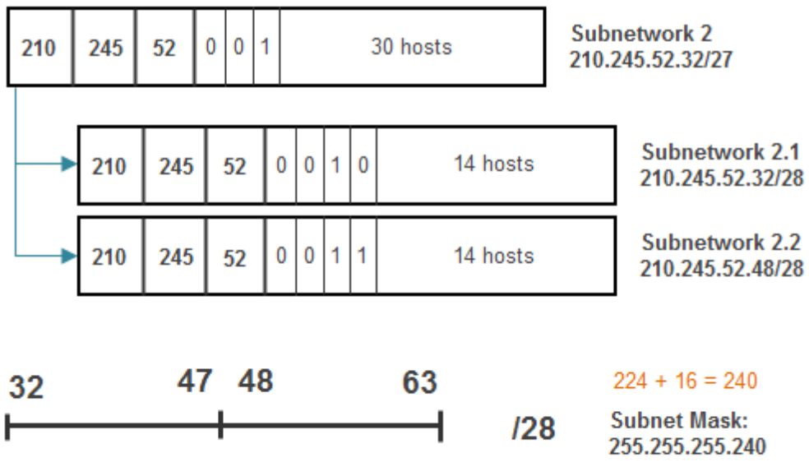

* Each subnetwork in the second level of division contains 14 hosts so we can use 1 subnetwork for FMT (10 PCs). For example, I use *subnetwork 2.1* for FMT.
* Subnetwork 2.1:

|  |  |  |
| --- | --- | --- |
| **1st address:** | **11010010.11110101.00110100.0010**0000 | (210.245.52.32) |
| **Subnet Mask:** | **11111111.11111111.11111111.1111**0000 | (255.255.255.240) |
| **Last address:** | **11010010.11110101.00110100.0010**1111 | (210.245.52.47) |

* Subnetwork 2.2:

|  |  |  |
| --- | --- | --- |
| **1st address:** | **11010010.11110101.00110100.0011**0000 | (210.245.52.48) |
| **Subnet Mask:** | **11111111.11111111.11111111.1111**0000 | (255.255.255.240) |
| **Last address:** | **11010010.11110101.00110100.0011**1111 | (210.245.52.63) |

* + Continue dividing subnetwork 2.2 into two smaller subnetwork...

*Let’s try it yourself!*

1. **Subnetting tips:** http://www.freesoft.org/CIE/Course/Subnet/109.htm
2. **References:**

http://www.tcpipguide.com/free/index.htm

<http://www.freesoft.org/CIE/Course/Subnet/>

**I I I . Exercise**

Say you’re responsible for administering IP network of a data center. There are three new rooms:

+ FIT needs 20 PCs

+ FMT needs 10 PCs

+ FCS needs 4 PCs

You’re given an IP block: 192.168.15.64/26. Please subnet the given IP block and assign the subnets to the three rooms.

Draw the network map using Packet Tracer and configure IP addresses for all PCs.

SOLUTION

**FIT:**

+ IP block: 192.168.15.64/27

+ Subnet mask: 255.255.255.224

+ Network address: 192.168.15.64

+ Broadcast address: 192.168.15.95

+ IP range: 192.168.15.64 – 192.168.15.95

+ IP range (for hosts): 192.168.15.65 – 192.168.15.94

+ Maximum number of hosts: 30

**FMT:**

+ IP block: 192.168.15.96/28

+ Subnet mask: 255.255.255.240

+ Network address: 192.168.15.96

+ Broadcast address: 192.168.15.111

+ IP range: 192.168.15.96 – 192.168.15.111

+ IP range (for hosts): 193.168.15.97 – 192.168.15.110

+ Maximum number of hosts: 14

**FCS:**

+ IP block: 192.168.15.112/29

+ Subnet mask: 255.255.255.248

+ Network address: 192.168.15.112

+ Broadcast address: 192.168.15.119

+ IP range: 192.168.15.112 – 192.168.15.119

+ IP range for host: 192.168.15.113 – 192.168.16.118

+ Maximum number of hosts: 6

**Other (reserved for future use):**

+ IP block: 192.168.15.120/29

+ Subnet mask: 255.255.255.248

+ Network address: 192.168.15.120

+ Broadcast address: 192.168.15.127

+ IP range: 192.168.15.120 – 192.168.15.127

+ Maximum number of hosts: 6